Project Design Phase-II
Data Flow Diagram & User Stories

Date | 29-11-2025
Team ID
Project Name | DocSpot- Doctor Appointing Booking System
Maximum Marks | 4 Marks

Data Flow Diagrams:
A Data Flow Diagram (DFD) visually represents the movement of data inside the Doctor Appointment Booking System.
It shows how Patients, Doctors, and Admins interact with the application, how appointment and medical data travel between modules, and how information is stored within the system.

DFD Level 0 – Doctor Appointment Booking System
The Level 0 DFD gives a top-level picture of the data flow in the Doctor Appointment Booking System.
It treats the entire application as a single process and highlights how information moves between the system and its external users — Patients, Doctors, and Admins.
This diagram outlines the basic flow of requests, approvals, appointment details, and medical records across all parties.
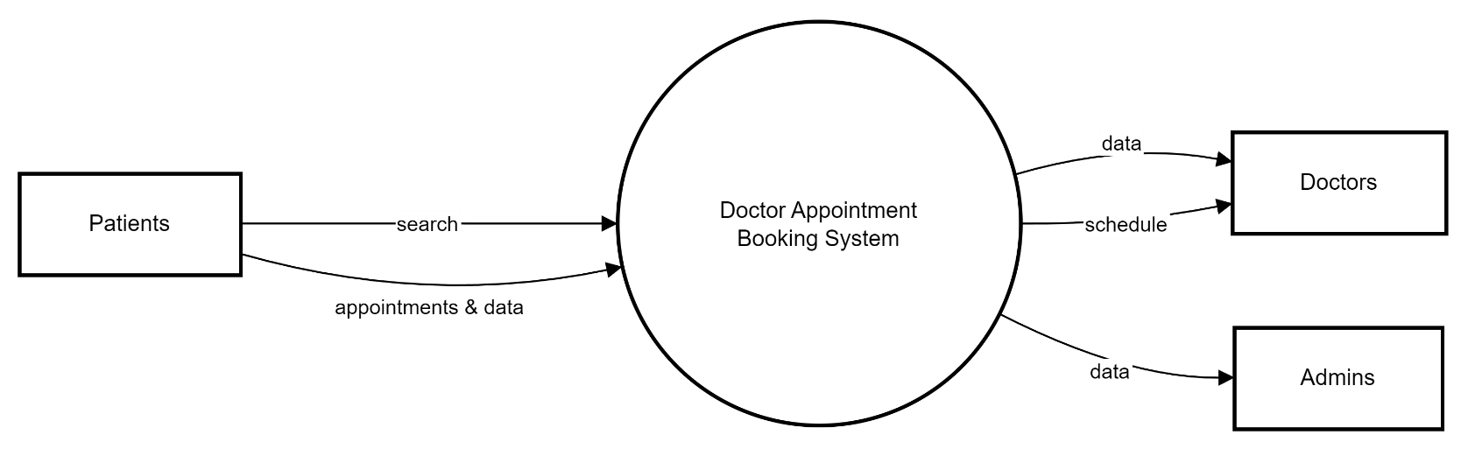

User Stories– Doctor Appointment Booking System
User Type | Functional Requirement | User Story / Task | Acceptance Criteria | Priority | Release
Patient | Doctor Search | As a patient, I want to look up doctors by their specialty so I can easily find the right one. | Search results must correctly list doctors based on selected filters. | High | Sprint 1
Patient | Appointment Booking | As a patient, I want to schedule appointments using available time slots. | Appointment should be successfully created and displayed for both patient and doctor. | High | Sprint 1
Patient | Appointment Management | As a patient, I want the option to cancel or modify my appointments. | Changes should update instantly for both doctor and patient dashboards. | Medium | Sprint 2
Patient | Medical Records | As a patient, I want access to my past consultations and prescriptions. | Logged-in users should see the correct historical records. | Medium | Sprint 2
Patient | Payments | As a patient, I want to pay for online consultations through the platform. | Payment must process successfully and generate a receipt. | High | Sprint 2
Patient | Notifications | As a patient, I want timely alerts for upcoming appointments. | Reminder should be triggered before the appointment time. | Low | Sprint 3
Doctor | Availability Setup | As a doctor, I want to configure my available consultation timings. | Patients should only see the time slots set by the doctor. | High | Sprint 1
Doctor | Appointment Dashboard | As a doctor, I want to view all my upcoming appointments. | The dashboard must show upcoming bookings with patient details. | Medium | Sprint 2
Doctor | Prescription Upload | As a doctor, I want to upload digital prescriptions for patients. | Uploaded prescriptions should appear in the patient’s medical records. | Medium | Sprint 3
Admin | Doctor Verification | As an admin, I want to validate and approve doctor registrations. | Only approved doctors can access their accounts and set timings. | High | Sprint 1
Admin | User Management | As an admin, I want the ability to manage doctor and patient accounts. | Admin should be able to activate, deactivate, or edit user accounts. | Medium | Sprint 2
Admin | System Monitoring | As an admin, I want to track all appointment logs and user activity. | Logs must show correct appointment and activity details. | Medium | Sprint 3

